# **Inspiration / Rejection**

Twitter (Bio Page)

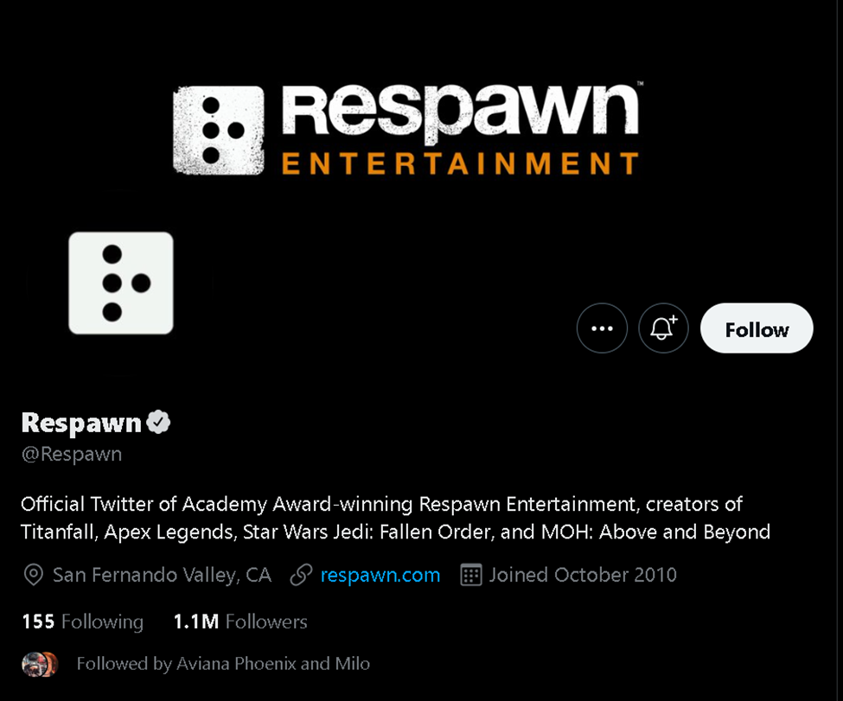

According to the internet the two most popular disucssion forums are quora and reddit.

Navbar

Reddits navigation bar is barely visible. Quora’s and twitters navigation bar looks nice, tumblr barely has any.

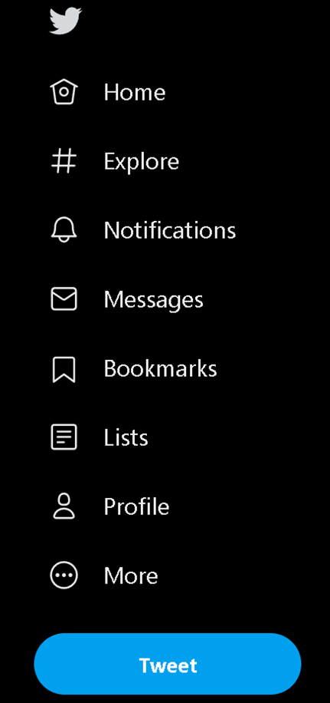



Tumblr has a nice square section for trending topics. We could use something similar to give user suggestions or topic suggestions.



Instagram’s desktop main feed is pretty cool. We could use something like this for when users post standalone images.

